sFLIM Matlab Pattern Matching Software Short Description

Requirements
Matlab 2019b mit folgenden Toolboxen:
- Image Processing Toolbox
- Parallel Computing Toolbox
A PC with good RAM memory (64 GB or more) and minimum 14 cores. As more cores the PC has, as faster the processing and calculation time will be.

Program description
The program consists of three parts:
- Preprocessing of the files (run TheProcessor.m)
- Pattern Maching analysis (run sFLIM.m)
- Reload of saved results (Plot_UnmixingResults.m)

Mark the corresponding m-file in Matlab and click F9

For the linear unmixing step, the Pattern Matching analysis, the m-files can be found here:
- sFLIM_Pattern_Matching_Fitting_vPat_Date
The algorithm works with a minimazation algorithm similar to least squares.
Example Data can be found here:
https://nc.picoquant.com/index.php/s/jxCmkHQWKrcZMXg

Processing of the files
The preprocessing of files generates TCSPC histogramms for each laser pulse and spectral detection channel and for each pixel.
The result are ...DATA.mat and ...FLIM.mat files which can be analyzed with the sFLIM Pattern Matching analysis.
- Several ptu files can be processed in parallel using all cores of the PC
- Optimize the number of files so that they can be distributed on your PC cores
- Each file needs RAM memory, too much file could lead to lower processing speed if RAM memory limit is exceeded
- run TheProcessor.m (mark the m file and click F9)

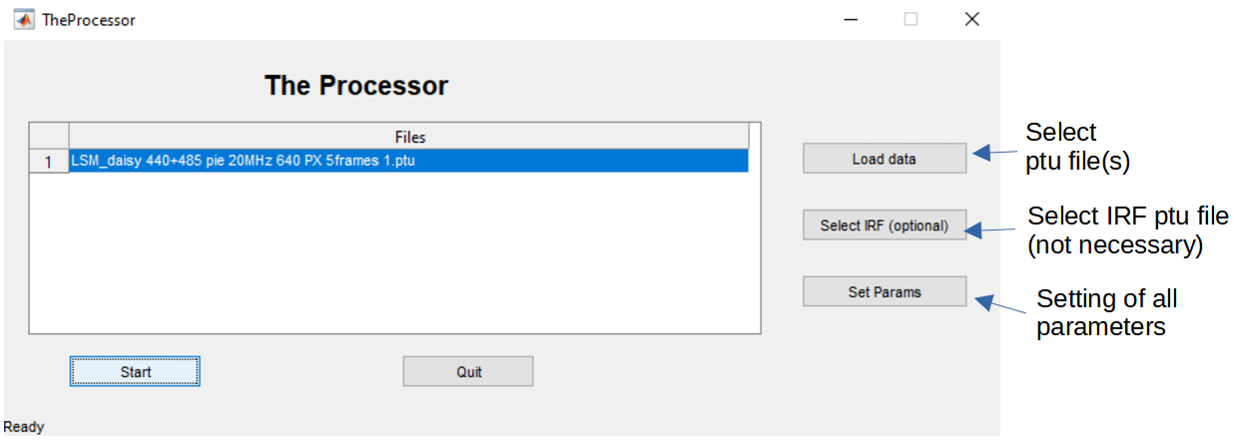

- select the ptu files
- select the IRF ptu files (this is not mandatory since the program is estimating the IRF from the measured files)
- click on „Set Params“ in case the parameters are not set beforehand (see parameter setting below) and enter all needed parameter
- mark the files in the list which you want to process
- click „Start“
- Once all files are processed, the status „Ready“ on the left lower corner will change to „Done“
  - Hint: you can use the task manager to observe the working of the PC on the files since there is no progress indicator

Setting of parameters

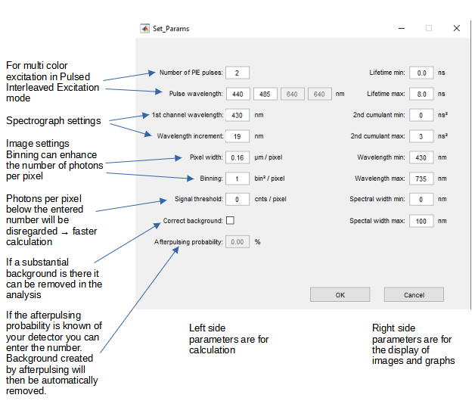
Background will be automatically esimated by the mean photon numbers in the first nanosecond of the TCSPC decay of the correponding channels.

In case the afterpulsing probability is given, background will be calculated using this number.

sFLIM Analysis graphical user interface
- Process your files using „TheProcessor.m“
- In order to start the sFLIM analysis run „sFLIM.m“ file (marking the file and click on F9)
- Overview of the graphical user interface:

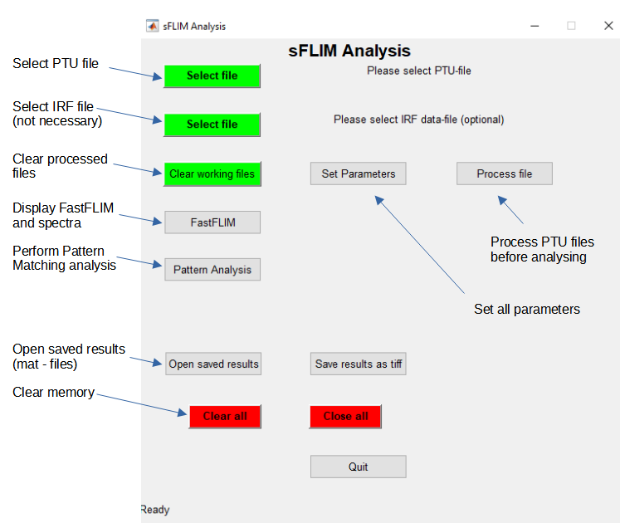

FastFLIM Display
- Select file
- If necessary set parameters
- Click on „FastFLIM“
The FastFLIM display opens the following display for each exciation wavelengths:
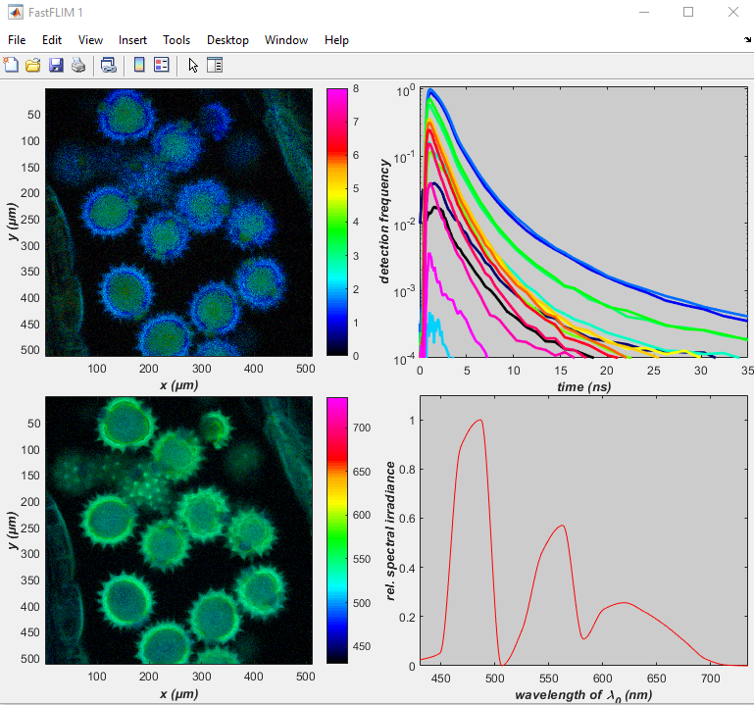
Upper left graph displays an average lifetime (in ns)
of all spectral channels summed together
Upper right graph shows the TCSPC histograms of all pixels. The spectral channels are color coded.

Lower right graph shows the spectra of all pixels and all TCSPC channels together
Lower left graph displays the average wavelength
(in nm) of all time channels summed together

Pattern Matching
- Select file
- If necessary set parameters
- Click on „Pattern Analysis“
- The FastFLIM display opens the following display for each exciation wavelengths
- Using the drop down menu „Detector channel“ the wavelengths included in the analysis can be selected. After changing the selection click on „Update“
- Using the drop down menu „pulse“ the excitation pulse corresponding to the excitation wavelength can be selected. For example using 440 nm and 485 nm excitation in PIE mode, „pulse 1“ refers to 440 nm and „pulse 2“ refers to 485 nm. All 4 graphs visible are displaying the result after excitation with the selected pulse. Do not forget to click on „Update“ after changing the pulse number.
- With Zoom parts of the images can be enlarged
- The upper left image is the FastFLIM image displaying the lifetime color coded
- The upper right image is a scatter plot indicating the frequency of pixels with certain properties, here displayed on the x – axis the mean lifetime and on the y – axis the square root of the second cumulant. It is in indication for the multiexponentiality of the lifetime decay. The value is low for mono-exponential decay and higher for a multi-exponentaily decaying samples.
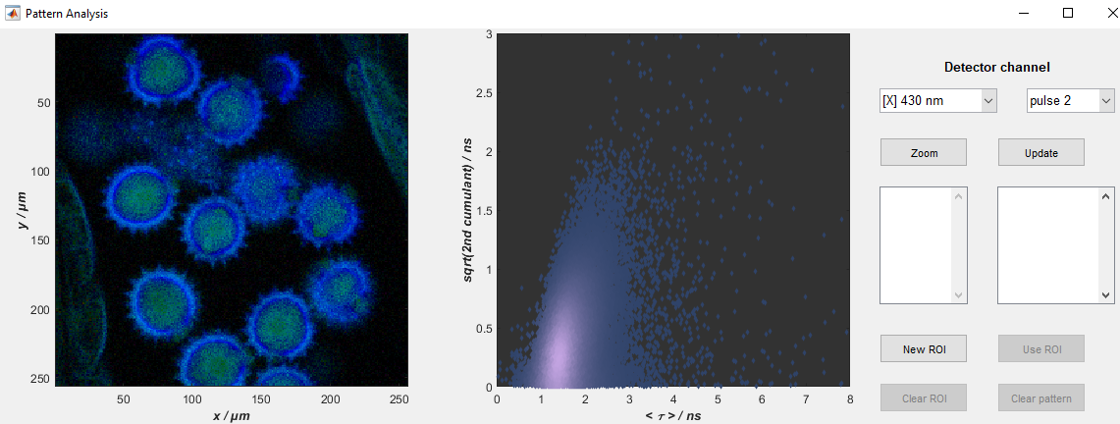
- In order to create patterns the first step is to define ROIs
- ROIs can be defined in all scatter plots and the image of the Pattern Analysis window
- ROIs can be defined separately for the different excitation wavelengths (pulse 1, 2 …)
- In order to create a ROI click on „New ROI“
- Now click in the graphs or image with left mouse button. Right mouse button will close the ROI.
- The ROIs are named …_1 or ..._2 indicating the laser pulse / excitation wavelength
- ROIs can be selected (they appear in blue color). Once selected the ROIs can be merged (Merge ROIs) or intersected (Intersection, only the pixels which are in both ROIs will be selected)
- As a next step Patterns can be created from the selected ROIs (marked in blue) by clicking on „Use ROI“.
- The Pattern contain all spectral and lifetime information (complete decays for every spectral detection channel)

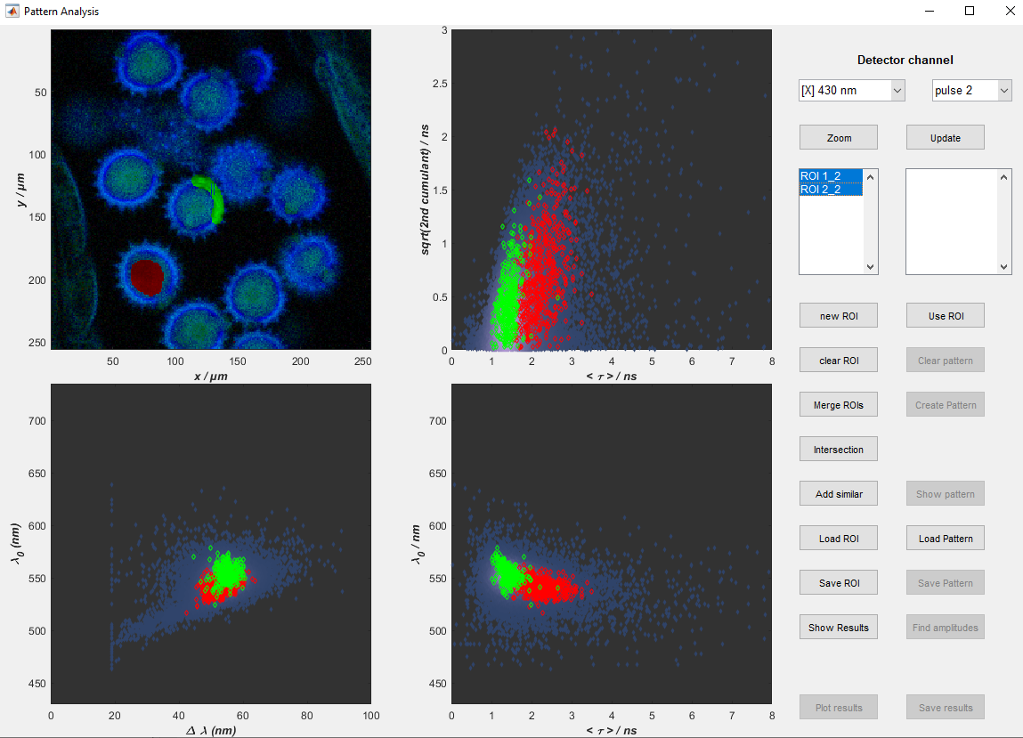
- The lower two panels displaying the mean wavelength over the width of the wavelengths distribution (left)
- The lower right panel displays the mean wavelength over the mean lifetime
- Once the Patterns are calculated clicking on „Use ROI“ they can be displayed by clicking on „Show Pattern“
- The following plot appears displaying the projection of the Pattern on the time axis (upper left plot, showing the lifetime decays) and on the wavelengths axis (upper lower plot, displaying the spectra). One Pattern is displayed in red, the other one in green.
- The complete infomation is displayed in a 3D graph on the right side. Visible are the two rows of decays belonging to the first excitation pulse (e.g. 440 nm) and the second excitation pulse (e.g. 485 nm) of the PIE excitation.

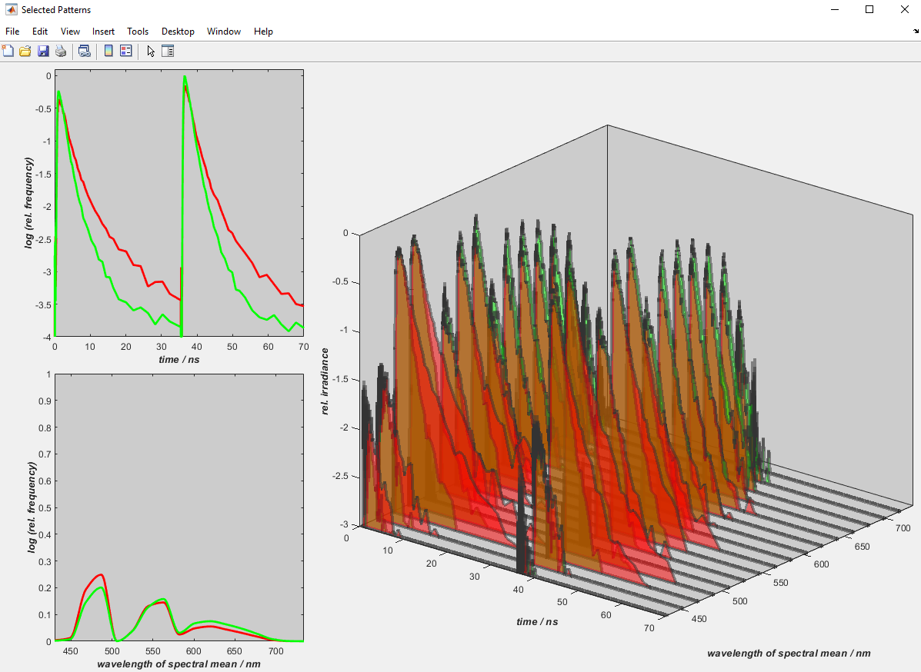
- Once the Pattern are created they can be saved for later usage clicking on „Save Pattern“. Each Pattern is saved as a separate file.
- The next step is the Pattern Matching step which can be started by clicking on „Find Amplitudes“
- The amplitude or intensity of each pattern in the image is calculated for every image pixel
- After clicking on „Find Amplitudes“ the following window appears

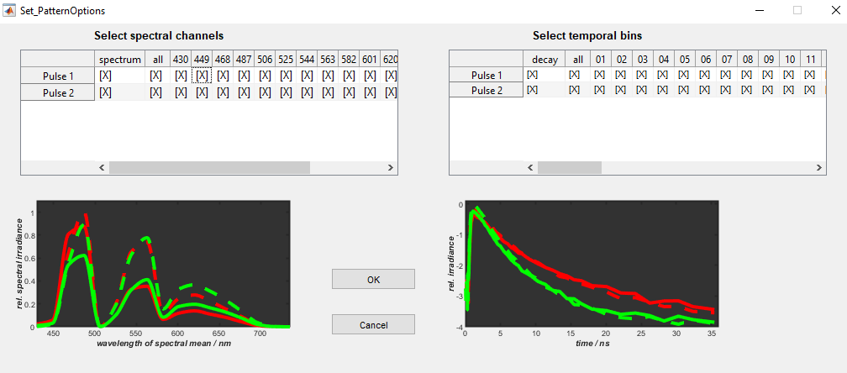

- Here all the spectral and timing channels can be used or the some of the channels can be selected / deselected
- For information the spectral and decay content is visualized in the graphs below
- Once the channel selection is optimized click on „OK“ to start the Pattern Matching process with is performed using an algorithm with a minimazation similar to least squares.
- The non-negativity of the algorithm makes sure that all amplitudes / brightnesses of the resulting images remain with positive values
- Once the Pattern Matching / linear unmixing is done, click on OK on the following information:
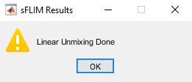
- Now you can click in the Pattern Analysis window on „Show Results“
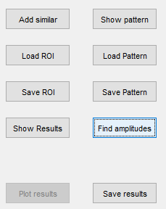
The results appear with several images.
  - One composite image in which the color and brightness of each Pattern in the image can be adjusted
  - One black/white image for every Pattern
  - One image indication the residuals which can be informative if the selected Pattern have been sufficient to describe the spectral / lifetime properties of the sample
- Finally the results can be saved with „Save results“

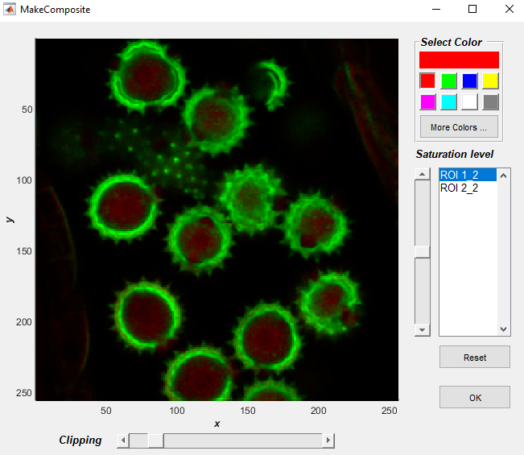
- Composite Image of the unmixing result using the two selected Pattern
- The color of the Pattern display (here named according to the selected ROIs) can be selected as well as the brightness
- The saved results can be opened with the routine „Plot_UnmixingResults.m“

Pattern Creation
Pattern creation from theoretical or measured parameters is very useful if the pattern of the desired fluorophore can not be measured directly because of e.g. underlying autofluorescence.
With the pattern creation tool not only the lifetimes of a selected pattern can be determined but also patterns created by the input of:
- absobtion spectra
- emission spectra
- lifetime parameters for a mono- or bi-exponential decay
The program assumes that the lifetime parameters remain constand thoughout the fluorescence emission spectra.
The Steps are the following:
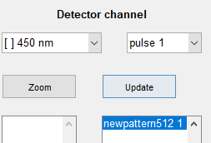
- Select a pattern which is most similar to what you expect to create
click on the selected pattern in the right window of the pattern analysis window:
- click on „Create Pattern“
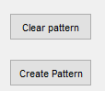
- The „Create Pattern“ window opens (see next page)

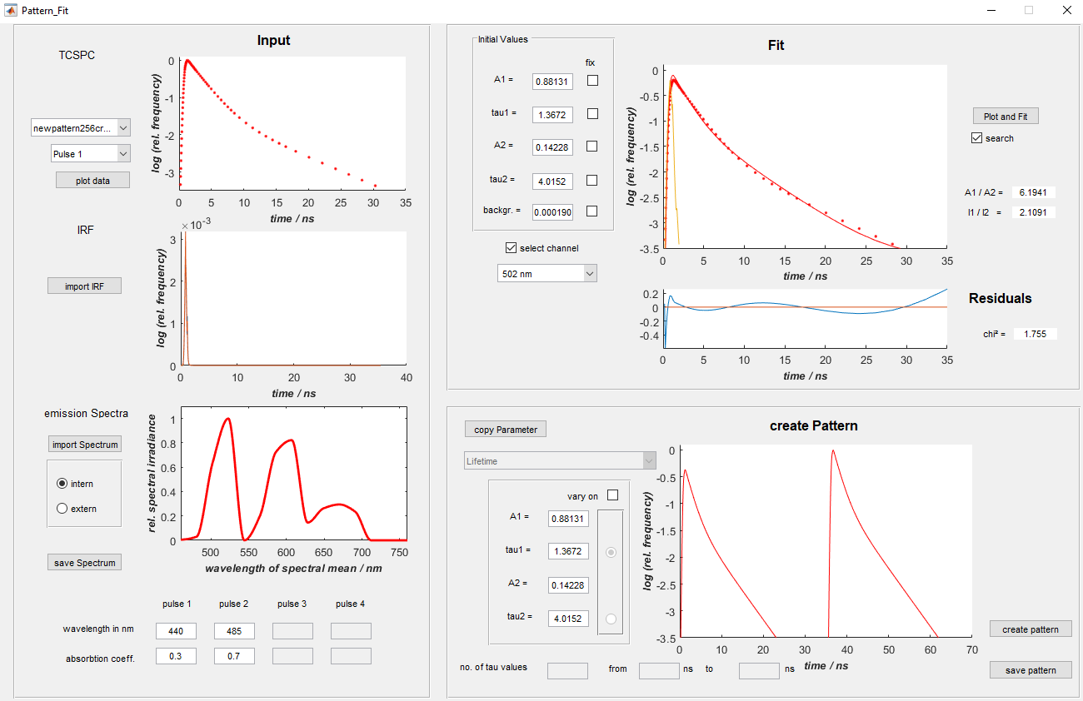
- As a first step select the pattern you want to use for the pattern creation (left upper side of the Pattern_Fit window)
- Click on „plot data“
- „plot data“ plots the pattern data (TCSPC, IRF (estimated or measured) and emission spectra)
- Now you can either take the emission spectrum as it was measured or by „save Spectrum“ and „import Spectrum“ you can use third party software to change it.
- If an external spectrum should be used, click on „extern“
- Enter the absorption coefficients of the fluorophore at the excitation wavelengths
- For the determination of the bi-exponential lifetime parameters slect the emission channel and click on „„Plot and Fit“ to fit the decay bi-exponentially
- In order to create Pattern you can either
  - click on „copy Parameter“ to take the fitted lifetime parameters in the „Fit“ section or
  - enter A1, A2, tau1, tau2
- Click on „create pattern“
- Save the pattern by clicking on „save pattern“
- Displayed is the decay of the spectral channel with the highest amplitude
- Once the pattern are saved, they can be used equally as measured pattern. However, they are free of noise as they are calculated.

Pattern Matching with a Variable Pattern
Up to now only fixed pattern, either created with the Pattern Creation tool or measured beforehand can be used to unmix the measurement of the sample. However, it would be interesting to detect lifetime variations of one interacting part of the sample. This can happen e.g. through FRET (Förster Resonance Energy Transfer) or by changes of the environment which influences the lifetime of the fluorescence.
Towards this the „Pattern Creation“ tool can not only create fix pattern but as well a family of pattern with spans a range of lifetimes or FRET efficiencies, the so called variable pattern. Each member of the pattern family is created with a certain lifetime distribution or FRET efficiency.
During the Pattern Matching process, for each pixel of the image the one pattern of the family is selected which gives the best fit in combination with the additional fixed pattern. In this way, for each pixel of the image a lifetime or FRET efficiency is calculated and as well the amplitudes of
- the selected pattern of the pattern family
- the additional fixed pattern.
The lifetime or FRET efficiency (whatever is selected during the Variable Pattern creation) is determind by the selected pattern of the Pattern Family which gives the best matching result.
How to create a variable pattern
The Pattern Matching process will be shown with an example.
Example file: FRET_GFP and mRFP.pt3 (see files in the FRET sample in Github)
This example has only one spectral channel. It shows a study of the proteins: GFP linked to
N-WASP, and mRFP linked to TOCA-1, the proteins are involved in filopodia and vesicle formation. Sample courtesy S. Ahmed, T. Sudhaharan, Institute of Medical Biology, Singapore.
Please start with these parameters the „TheProcessor.m“ and select the FRET example.
Enter the following parameter settings:
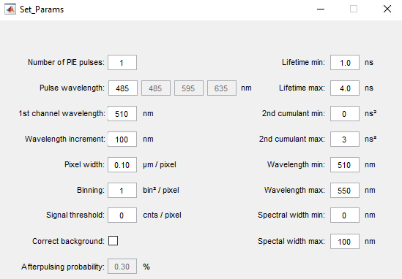
Please run the „TheProcessor.m“, enter the parameters and select the FRET example.
Now run in Matlab sFLIM.m file and select the sample file FRET_GFP and mRFP.pt3.
Pattern (ROI) selection:
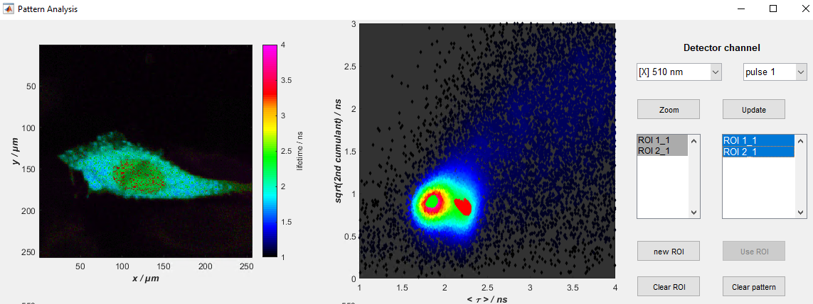
The pattern can be easily selected in the scatter plot depicting the mean lifetime on the x-axis and the square root of the 2nd cumulant. Here, ROI1_1 is depicted in red color and is located in the green regoin of the scatter plot with a lifetime of around 2.2 ns. This region selects the nucleus area in the FLIM image. TOCA-1, the protein labeled with the acceptor fluorophore, can not enter the nucleus. This is the reason the in the nucleus, only the donor fluorophore GPF is abundant and the acceptor is missing. ROI1_1 can be used to derive the the donor-only pattern.
The ROI2_1 (in green) highlights the pixel where FRET takes place and the lifetime is shortened due to FRET. Therefore it can be used to dervice the FRET pattern.

- In order to create the FRET pattern family we select only ROI1_1 (the donor pattern) and click on „Create Pattern“.
- In the Pattern_Fit window (left upper side) click now on „plot data“
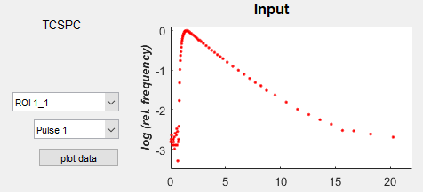
- The decay curve becomes visible
- Now enter „1“ as absorbtion coefficent (lower left of the Pattern_Fit window)
  - Since there is only 485 nm as excitation we can set the coefficent equal to 1.
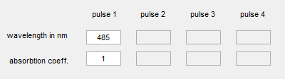
- Then click on the right side „Plot and Fit“
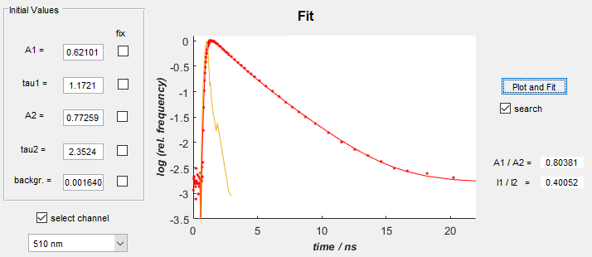
Here we see that the donor GFP fluorescence has already two lifetimes of 2.4 ns and 1.2 ns.
- In the „create Pattern“ section please click on „vary on“.
- Now you can select between different options:
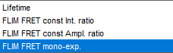
Lifetime: Here the lifetime as parameter is fitted. On can choose which lifetime parameter will be varied (checkbox „vary on“) and which remains fixed. Below the number of pattern created with different lifetime values can be set (here 11). In this way the tau2 value is varied between 1 and 3 ns. Other parameters A2, A1, tau1 remain as entered.
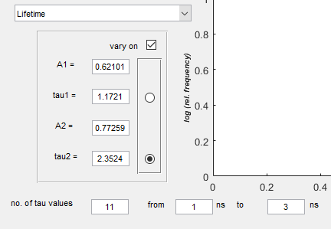
For FRET evaluation, either the intensity ratio between both lifetime components or the amplitude ratio can be kept constant. In this way bi-exponential FRET decays can be generated.
Often the FRET component remains mono-exponential, even if the donor-only lifetime is comprised of a bi-exponential decay. Therefore the last model „FLIM-FRET mono-exp.“ creates pattern with a mono-exponential decaying FRET component.
- Lets choose FLIM FRET mono-exp.
- As lifetime The tau2 value is selected 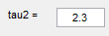, here the donor-only lifetime should be entered. In this example we set tau2 to equal 2.3 ns. This is the longer lifetime component of GFP which has a bi-exponential decay. FRET is more likely to act on the longer lifetime component of the FRET donor.
- Before clicking on „create pattern“ please enter the „absorbtion coefficient“ (lower left of the window). Since the measurement in this case was only excited with one wavelength, we can set it to 1.0. This example was excitated only with 485 nm laser, so pulse 1 is excitation with this wavelength.
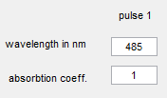
- Now the number of pattern which are calculated for the pattern family can be entered. In addition the range of FRET efficiencies should be set:
- Click on „create pattern“
The result looks like the following:
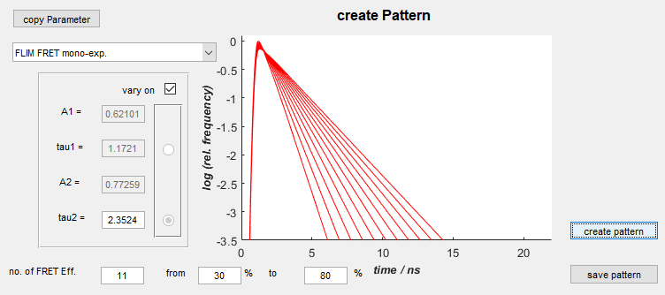
The pattern include the IRF estimation and are normalized so that the area under the curves is always constant. This is equivalent to a constant number of photons contributing to each pattern.
100% FRET efficiency in this case would create a decay with a lifetime equal to the tau2 value.
The calculation of the variable lifetime component tau(var) is:
tau(var) = tau2 * (100% - FRETeff(%))/100%
The pattern family consiting of 11 pattern ranging from 30% FRET efficiency to 80% FRET efficiency are created
The pattern family can be saved clicking on „save pattern“. The pattern will be saved as *.vpat as extension since it is a veriable pattern comprised of a pattern family.
- As a next step we go back to the Pattern Analysis window and save the pattern of
- ROI1_1 as „Donor-only.pat“
and
- ROI2_1 as „FRET.pat“
by selecting the ROI1_1 and ROI2_1 in the right window and click on „Save pattern“ respectively.
- Now one important point is that the pattern family must be loaded first. Therefore we select both ROI1_1 and ROI2_1 in the right selection window and click on „Clear Pattern“.
- Now we click on „Load Pattern“. In the selection window variable pattern is selected from the drop down menu and select the just created variable pattern from the list.
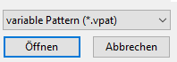
In this way the variable pattern „FRET 30 – 80“ will be loaded.
- In a second step we load as a fixed pattern the donor-only.pat pattern which as well was just created. Now we select both pattern.

The result looks as follows:
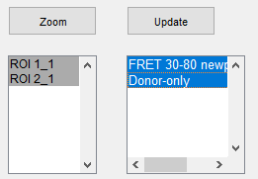
The first in the list is the variable pattern, the second in the list the donor-only pattern. There could be more fixed pattern added like e.g. auto-fluorescence or background pattern depending on the sample. However, currently the maximum number of variable pattern is one.
- Now click on „Find amplitudes“
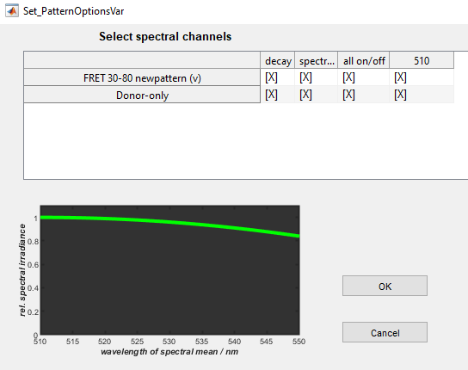
- Since the sample has only one excitation wavelengt and detection channel, there is nothing more to select. Klick on OK to start the linear unmixing and pattern matching step.
- Once the unmixing is done, klick on „Show Results“ in the „Pattern Analysis“ window.
After optimizing the intesities for the two channels the composite image shows the donor-only contribution in green and the FRET contribution in red:
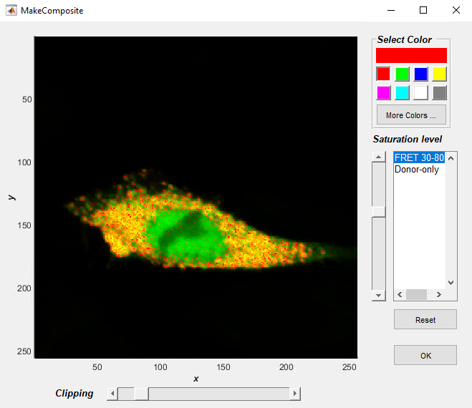
It can be seen that in the nucleus only donor-only contributions can be found while in the vesicles FRET takes place. However, in all pixels donor-only is abundant, too.
Therefore it would be interesting to see quantitatively, how much is the contribution of FRET and donor-only in the pixels. This is calculated by the Binding figure, which is calculated by:
Binding = A(FRET component) / (A(donor-only) + A(FRET component)) * 100
„A“ is the amplitude in each pixel of the respective component.
The resulting color scale image gives the so called Binding in percent (see next image).
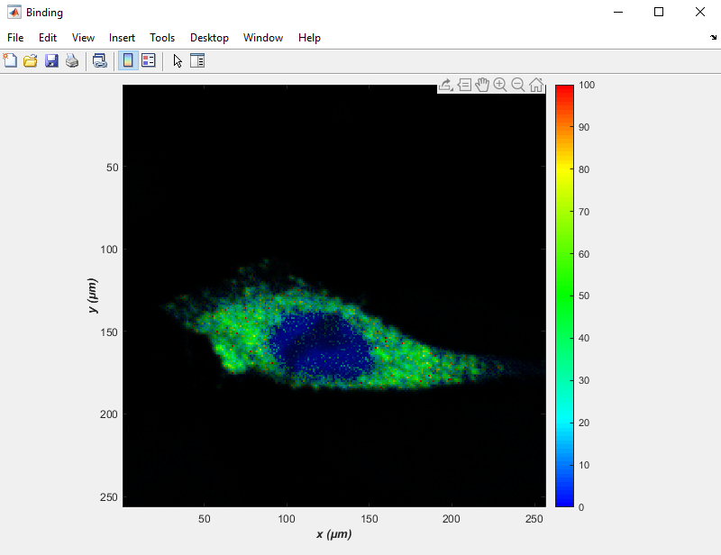
The Binding reaches 40% to 50% in the vesicles / cytoplasm. In the nucleus it is 0% indicating that no FRET takes place.
The next figure shows the FRET Efficiency in percent.
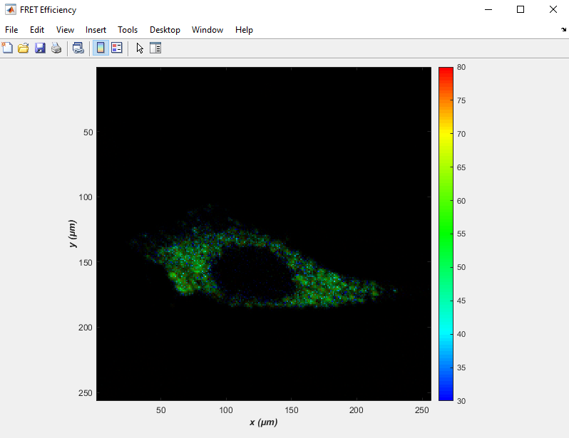
The next images shows the residuals. It displays where the unmixing and pattern matching process did not work out completely. This image is the sum of the umixed intensity images minus the original intensity image.

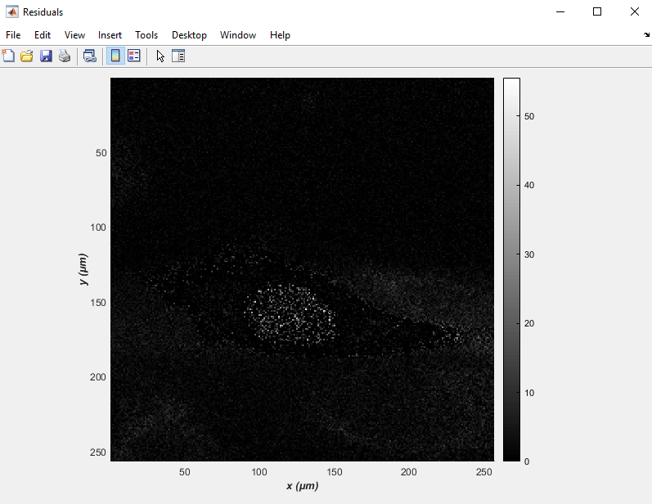
The last two images are the two intensity images of the FRET and donor-only component respectively, see next page.
Donor-only component:
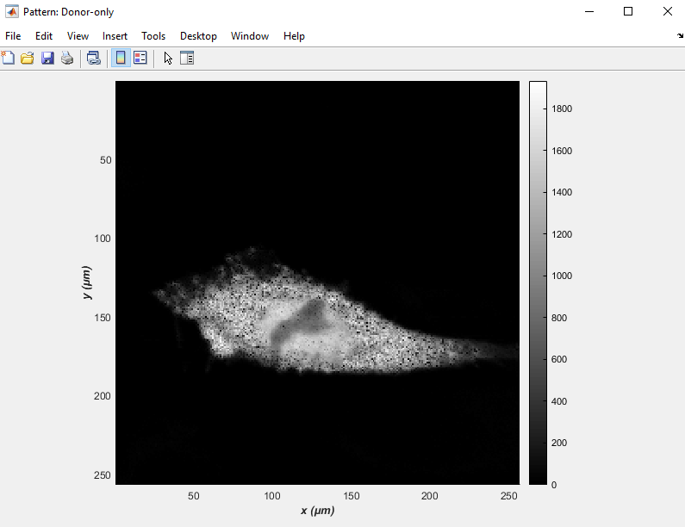

FRET component:
